Directory is a folder used to organize files, while a library is a collection of reusable code or functionality.
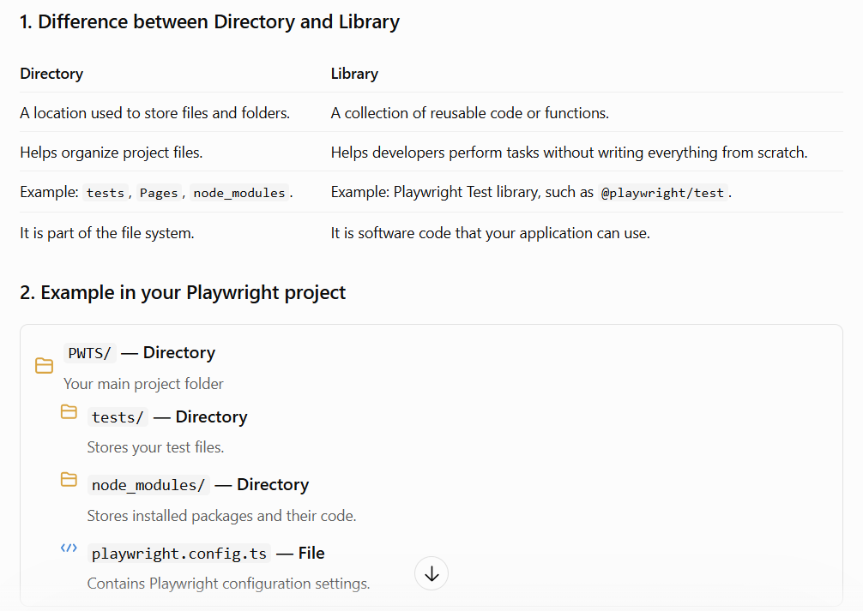
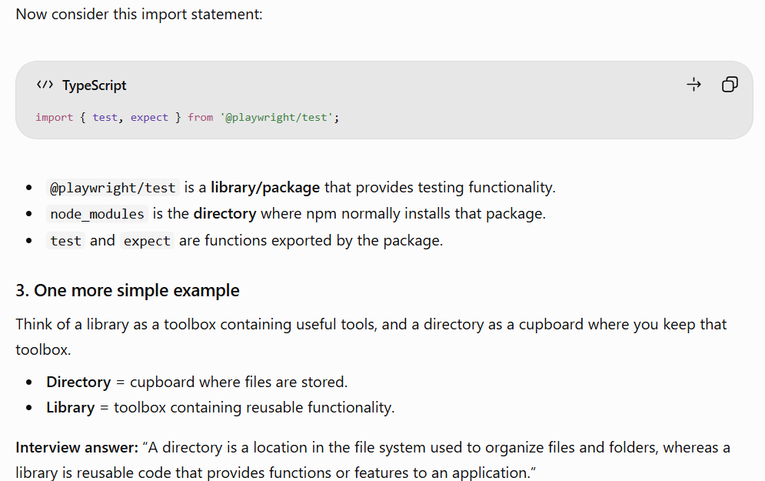
VS Code icons and their uses
1. Explorer — Files and folders
Most important
Shows your project files and folders, such as tests, Pages, node_modules, package.json, and playwright.config.ts.
Need: Create files, open test scripts, organize folders, and manage your project.
2. Search — Find text in your project
Need: Find a variable, method, locator, or text across multiple files.
Example: Search for LoginPage to find every place it is used.
Shortcut: Ctrl + Shift + F
3. Source Control — Git
Need: Track code changes, commit your work, create branches, and sync with GitHub.
Example: Save a version of your Playwright test using a Git commit.
Useful when working with a team.
4. Run and Debug — Debugging tools
Need: Run and debug your code, set breakpoints, and inspect variable values while a test executes.
Example: Pause your login test after entering the username to see why the next step is failing.
5. Extensions
Need: Install additional features in VS Code.
Example: Install the Playwright extension to help run tests, inspect test results, and debug tests from the editor.
6. Testing
Need: View and run tests through the editor's testing interface.
With the Playwright extension installed and configured, you can discover Playwright tests, run individual tests, and debug them without always typing commands in the terminal.
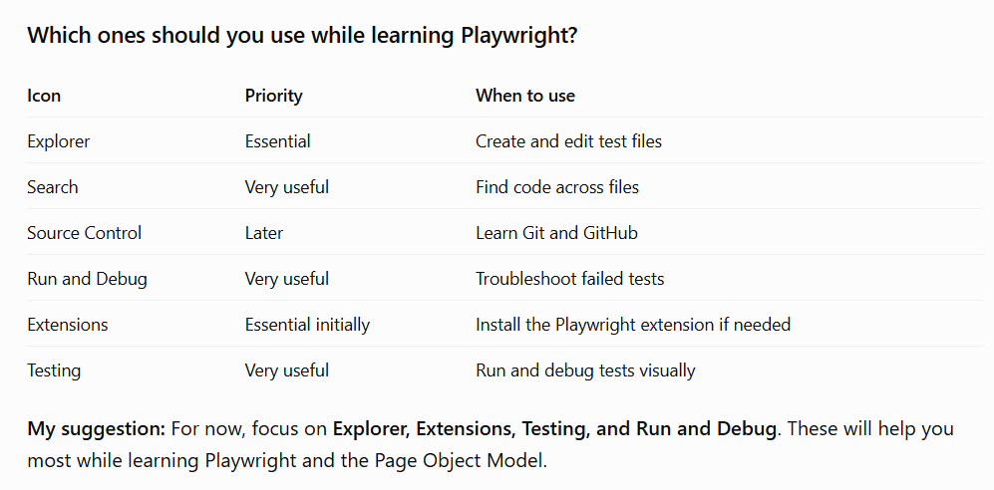
Here are VS Code interview questions and answers based on the six icons you shared. These are useful for a Playwright with TypeScript interview, explained in simple English.
1. Basic VS Code interview questions
Q1. What is VS Code?
Answer: Visual Studio Code is a code editor used to write, edit, debug, and manage code. We use it to develop Playwright automation scripts using TypeScript or JavaScript.
Q2. What is the Explorer in VS Code?
Answer: Explorer displays the files and folders in our project. We can create, rename, delete, and open files from there.
Q3. What is the Search option used for?
Answer: Search helps us find specific words, variables, methods, or code across multiple files in our project.
Q4. What is Source Control in VS Code?
Answer: Source Control integrates with Git to help us track code changes, stage files, commit changes, and work with branches.
Q5. What is the Run and Debug option?
Answer: It helps us execute and debug code. We can set breakpoints, inspect variables, and understand where a program is failing.
Q6. What are Extensions in VS Code?
Answer: Extensions add extra features to VS Code. For example, the Playwright extension helps us run, view, and debug Playwright tests from the editor.
Q7. What is the Testing icon used for?
Answer: It opens the Testing view, where supported tests can be discovered and executed. With the Playwright extension, we can view and run individual Playwright tests.
2. Playwright-specific interview questions
Q8. How do you run a Playwright test from VS Code?
Answer: We can run a test using the Playwright Testing extension, the Run button displayed above a test, or the terminal command:
npx playwright test
Q9. How do you debug a failed Playwright test?
Answer: We can set a breakpoint in VS Code and run the test in debug mode. We can inspect variables and execute the code step by step.
Q10. What is a breakpoint?
Answer: A breakpoint pauses program execution at a selected line so that we can inspect what is happening.
Q11. How do you find a method used in multiple Playwright files?
Answer: Use the Search icon or press Ctrl + Shift + F, then enter the method name.
Q12. What is the difference between Run and Debug?
Answer:
- Run: Executes the code normally.
- Debug: Executes the code with tools to pause execution and inspect variables, depending on the debugging configuration.
Q13. Why do we use the Playwright extension in VS Code?
Answer: It integrates Playwright tests into the editor, helping us discover tests, run specific tests, debug them, and inspect test results.
Q14. Can we run Playwright tests without the Testing icon?
Answer: Yes. We can run tests directly from the terminal using npx playwright test, provided the project is configured correctly.
3. Git and Source Control interview questions
Q15. What is Git?
Answer: Git is a version control system that tracks changes in files and allows developers to maintain different versions of their code.
Q16. What is the difference between Git and GitHub?
Answer: Git is a version control tool. GitHub is an online platform where Git repositories can be hosted and shared.
Q17. What is staging in Git?
Answer: Staging means selecting the changes that we want to include in the next commit.
git add .
This stages eligible changes in the current directory and its subdirectories.
Q18. What is a Git commit?
Answer: A commit records a snapshot of staged changes in the repository's history.
git commit -m "Added login test"
Q19. What is the purpose of .gitignore?
Answer: It tells Git to ignore specified untracked files and folders, such as node_modules and generated test reports.
4. Scenario-based interview questions
Q20. You cannot find a method in a large project. What will you do?
Answer: I will use global search with Ctrl + Shift + F to search for the method name across the project.
Q21. Your Playwright test is failing, and you do not know why. What will you do?
Answer: I will check the error message, use debugging or breakpoints, inspect locator values, and examine the test report or trace.
Q22. You want to run only one test instead of the entire suite. How can you do it?
Answer: I can use the Run option above the individual test in VS Code or use:
npx playwright test tests/login.spec.ts
This runs the tests in that file. To run a specific test by title:
npx playwright test -g "login test"
Q23. The Testing icon does not display your Playwright tests. What will you check?
Answer: I will check whether the Playwright extension is installed and enabled, whether the correct project folder is open, whether the test files match Playwright's discovery patterns, and whether the project dependencies are installed.
Q24. You want to save your code changes in Git. Which VS Code option will you use?
Answer: I will use Source Control to review changes, stage the required files, enter a commit message, and commit them.
5. Quick mock interview
Try answering these questions yourself. Select an answer and check your score.
1. Which VS Code icon shows project files and folders?
Search
Explorer
Source Control
Correct!
Explorer displays project files and folders.
2. Which feature pauses code execution on a selected line?
Breakpoint
Extension
Commit
Correct!
A breakpoint pauses execution so you can inspect the program.
3. Which shortcut opens global search?
Ctrl + S
Ctrl + Shift + F
Ctrl + P
Correct!
Ctrl + Shift + F searches across files in the project.
4. Which command runs Playwright tests from the terminal?
npm search
git commit
npx playwright test
Correct!
This command runs tests discovered by Playwright.
5. Which VS Code view helps you run discovered Playwright tests?
Testing
Explorer only
Source Control
Correct!
The Testing view, with the Playwright extension, helps you run and debug tests.
Here are the most important Git interview questions and answers for a Playwright automation tester, explained in simple English with practical commands.
Since you're learning Playwright with TypeScript in VS Code, I've included examples of how Git is used to manage your automation project.
1. Basic Git interview questions
Q1. What is Git?
Answer: Git is a distributed version control system used to track changes in code. It helps developers maintain code history, work in teams, and restore earlier versions when needed.
Q2. Why do we use Git in Playwright?
Answer: We use Git to:
- Track changes in test scripts.
- Maintain Page Object Model (POM) classes.
- Collaborate with other automation testers.
- Create branches for new features.
- Share code through platforms such as GitHub.
Q3. What is the difference between Git and GitHub?
Git | GitHub
A version control tool. | An online platform for hosting Git repositories.
Tracks changes locally. | Helps teams share and collaborate on repositories online.
Can work without an internet connection for local operations. | Usually requires a network connection for remote collaboration.
Q4. What is a repository?
Answer: A repository, or repo, is a location where Git manages your project's files and version history.
There are two common types:
- Local repository: Stored on your computer.
- Remote repository: Stored on a server, such as GitHub.
Q5. What is the difference between a file and a repository?
Answer: A file contains code or data. A repository manages project files and their version history.
2. Important Git commands
Q6. How do you initialize a Git repository?
git init
This initializes Git in the current directory.
Q7. How do you check the status of files?
git status
It shows modified files, untracked files, and staged changes.
Q8. What is git add?
Answer: It stages changes that you want to include in your next commit.
git add .
This stages eligible changes in the current directory and its subdirectories.
Q9. What is git commit?
Answer: It records staged changes in the repository's history.
git commit -m "Added login test"
Q10. What is git log?
Answer: It displays the commit history.
git log
For a shorter view:
git log --oneline
Q11. What is git clone?
Answer: It downloads a copy of an existing repository, including its Git history.
git clone https://github.com/username/project.git
Q12. What is git pull?
Answer: It fetches changes from a remote repository and integrates them into your current branch.
git pull
Q13. What is git push?
Answer: It uploads your local commits to a remote repository.
git push
Q14. What is git fetch?
Answer: It downloads updates and remote-tracking information without automatically merging those changes into your current branch.
git fetch
3. Git branching interview questions
Q15. What is a branch in Git?
Answer: A branch is an independent line of development. It lets us work on new features without directly changing the main branch.
Example: You create a branch to develop a new Playwright login test.
git branch login-feature
Q16. How do you check the current branch?
git branch
The asterisk (*) indicates your current branch.
Q17. How do you switch branches?
git switch login-feature
Q18. How do you create and switch to a new branch in one command?
git switch -c login-feature
Q19. What is merging in Git?
Answer: Merging combines changes from one branch into another.
For example, to merge login-feature into main:
git switch main
git merge login-feature
Q20. What is the difference between git merge and git rebase?
- Merge: Combines branch histories, usually creating a merge commit when needed.
- Rebase: Replays commits onto another base commit, creating a different commit history.
4. Git staging and file management questions
Q21. What is the difference between git add and git commit?
git add | git commit
Stages changes. | Saves staged changes as a commit.
Prepares changes for recording. | Records a snapshot in Git history.
Q22. What is an untracked file?
Answer: A file that Git has not started tracking.
For example, when you create a new LoginPage.ts file, Git may show it as untracked until you add it.
Q23. What is .gitignore?
Answer: It specifies patterns for files and folders that Git should ignore when they are untracked.
Example:
node_modules/
playwright-report/
test-results/
Q24. What is the difference between git diff and git status?
- git status shows which files have changed and whether they are staged.
- git diff shows the actual content differences between versions of files.
Q25. How do you discard unstaged changes in a file?
git restore LoginPage.ts
This discards unstaged changes in that file. Be careful: the discarded changes may be difficult to recover.
Q26. What is git stash?
Answer: It temporarily saves changes so you can work on something else without committing them.
git stash
To restore the most recently stashed changes:
git stash pop
5. Scenario-based Git interview questions
Q27. You have modified your Playwright test and want to upload it to GitHub. What steps will you follow?
Answer:
git status
git add .
git commit -m "Updated login test"
git push
Before pushing, ensure you are on the correct branch and that the remote repository is configured.
Q28. Two testers modify the same lines of a file. What can happen?
Answer: A merge conflict can occur when Git cannot automatically combine their changes.
We need to open the affected file, resolve the conflicting sections, stage the resolved file, and complete the merge or rebase.
Q29. What is a merge conflict?
Answer: It occurs when Git cannot automatically reconcile changes from different branches.
For example, two testers change the same login method in LoginPage.ts.
Q30. You accidentally committed a change. How can you undo it safely?
Answer: If you want to create a new commit that reverses an earlier commit, use:
git revert <commit-id>
This is often safer for commits already shared with teammates because it preserves history.
Q31. What is the difference between git reset and git revert?
- git reset moves the current branch reference and can change staging or working files, depending on the option.
- git revert creates a new commit that reverses the changes introduced by an earlier commit.
Q32. You cloned a project but cannot run its Playwright tests. What would you check?
Answer: I would check whether dependencies are installed, the correct project folder is open, and the required browsers are installed.
npm install
npx playwright install
npx playwright test
Q33. What is a pull request (PR)?
Answer: A pull request is a request to review and merge changes from one branch into another on a platform such as GitHub.
Q34. What is origin in Git?
Answer: origin is the conventional default name for a remote repository.
Example:
git push origin main
This pushes the local main branch to the remote named origin.
6. Quick revision: Git commands
Command | Purpose
git init | Initialize a repository
git clone | Copy a remote repository
git status | Check working-tree status
git add . | Stage eligible changes
git commit -m "message" | Create a commit
git push | Upload local commits
git pull | Fetch and integrate remote changes
git fetch | Download remote updates
git branch | List branches
git switch -c feature | Create and switch to a branch
git merge feature | Merge a branch
git stash | Temporarily save changes
git log --oneline | View compact commit history
git diff | View changes
7. Practice mock interview
1. Which command stages changes?
git push
git add
git log
2. Which command creates a commit?
git commit
git fetch
git clone
3. Which command creates and switches to a branch?
git merge
git switch -c feature
git status
4. Which command downloads remote updates without integrating them into your current branch?
git fetch
git pull
git revert
5. Which Git feature specifies files that should be ignored?
package.json
playwright.config.ts
.gitignore
Check answers

